Experiment 13:
Source code:
#include <reg51.h>

void main()
{
unsigned int numbers[5];
unsigned long sum;
unsigned char i;

numbers[0] = 0x1111;
numbers[1] = 0x2222;
numbers[2] = 0x3333;
numbers[3] = 0x4444;
numbers[4] = 0x5555;

sum = 0;

for(i = 0; i < 5; i++)
{
sum = sum + numbers[i];
}

/* Store 32-bit result in internal RAM */
*((unsigned char data *)0x30) = sum & 0xFF;
*((unsigned char data *)0x31) = (sum >> 8) & 0xFF;
*((unsigned char data *)0x32) = (sum >> 16) & 0xFF;
*((unsigned char data *)0x33) = (sum >> 24) & 0xFF;

while(1);
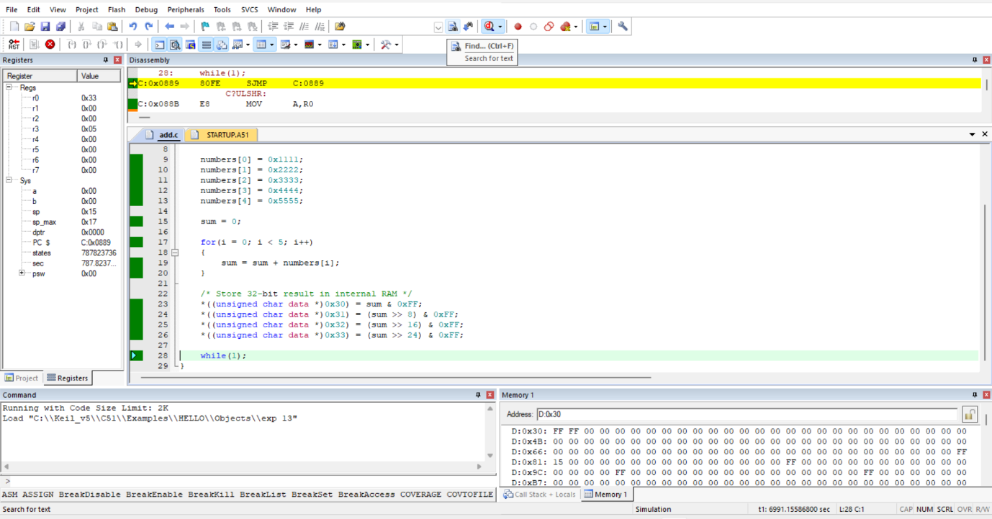
}
Output:

